|  |  |  |
| --- | --- | --- |
| Storage | * S3 Overview * Storage Classes and its types * Encryption, Versioning and Bucket Policies * S3 Events and Lifecycle Management | **Section 12 - ( 129 - 141 )**  **Section 13 - (142 - 143, 145 - 146)**  **Section 14 - (150 - 153 )** |

1.  A large media company stores millions of video files in their cloud storage. They have the following requirements:

* Files that haven't been accessed for 90 days should be automatically deleted to optimize storage costs
* However, some files might be old but frequently accessed (like classic movies) - these should be preserved regardless of their age.
* The solution should be automated and scalable.
* There should be a way to track which files were deleted
* The deletion process should be cost-effective and not impact the performance of active file access

Design a cloud-based solution that addresses these requirements. Your solution should minimize operational overhead while ensuring reliable file management.

Requirements:

* Explain your choice of services and their roles – AWS S3
* Describe how files will be tracked for access patterns. – Intelligent Tiering
* Detail the automation process for identifying and deleting unused files
* Discuss any potential challenges and how to address them
* Consider cost optimization aspects of your solution

1. You're a cloud engineer for a large research institution that stores massive amounts of scientific data in Amazon S3. The institution has recently faced issues with accidental deletions and needs to implement better data protection measures. Additionally, they frequently need to perform large-scale operations on their data sets.

* The institution has a primary S3 bucket named "science-data-2024" containing terabytes of research data.
* ﻿﻿﻿Recently, a researcher accidentally deleted a folder containing crucial experiment results.
* ﻿﻿﻿The institution often needs to update metadata tags on millions of files based on new classification criteria.

Requirements:

1. ﻿﻿﻿Implement a solution to protect against accidental deletions and allow easy recovery of deleted data.

Ans : Enable Versioning

1. ﻿﻿﻿Set up a process to efficiently update metadata tags on millions of objects without downloading and re-uploading them.

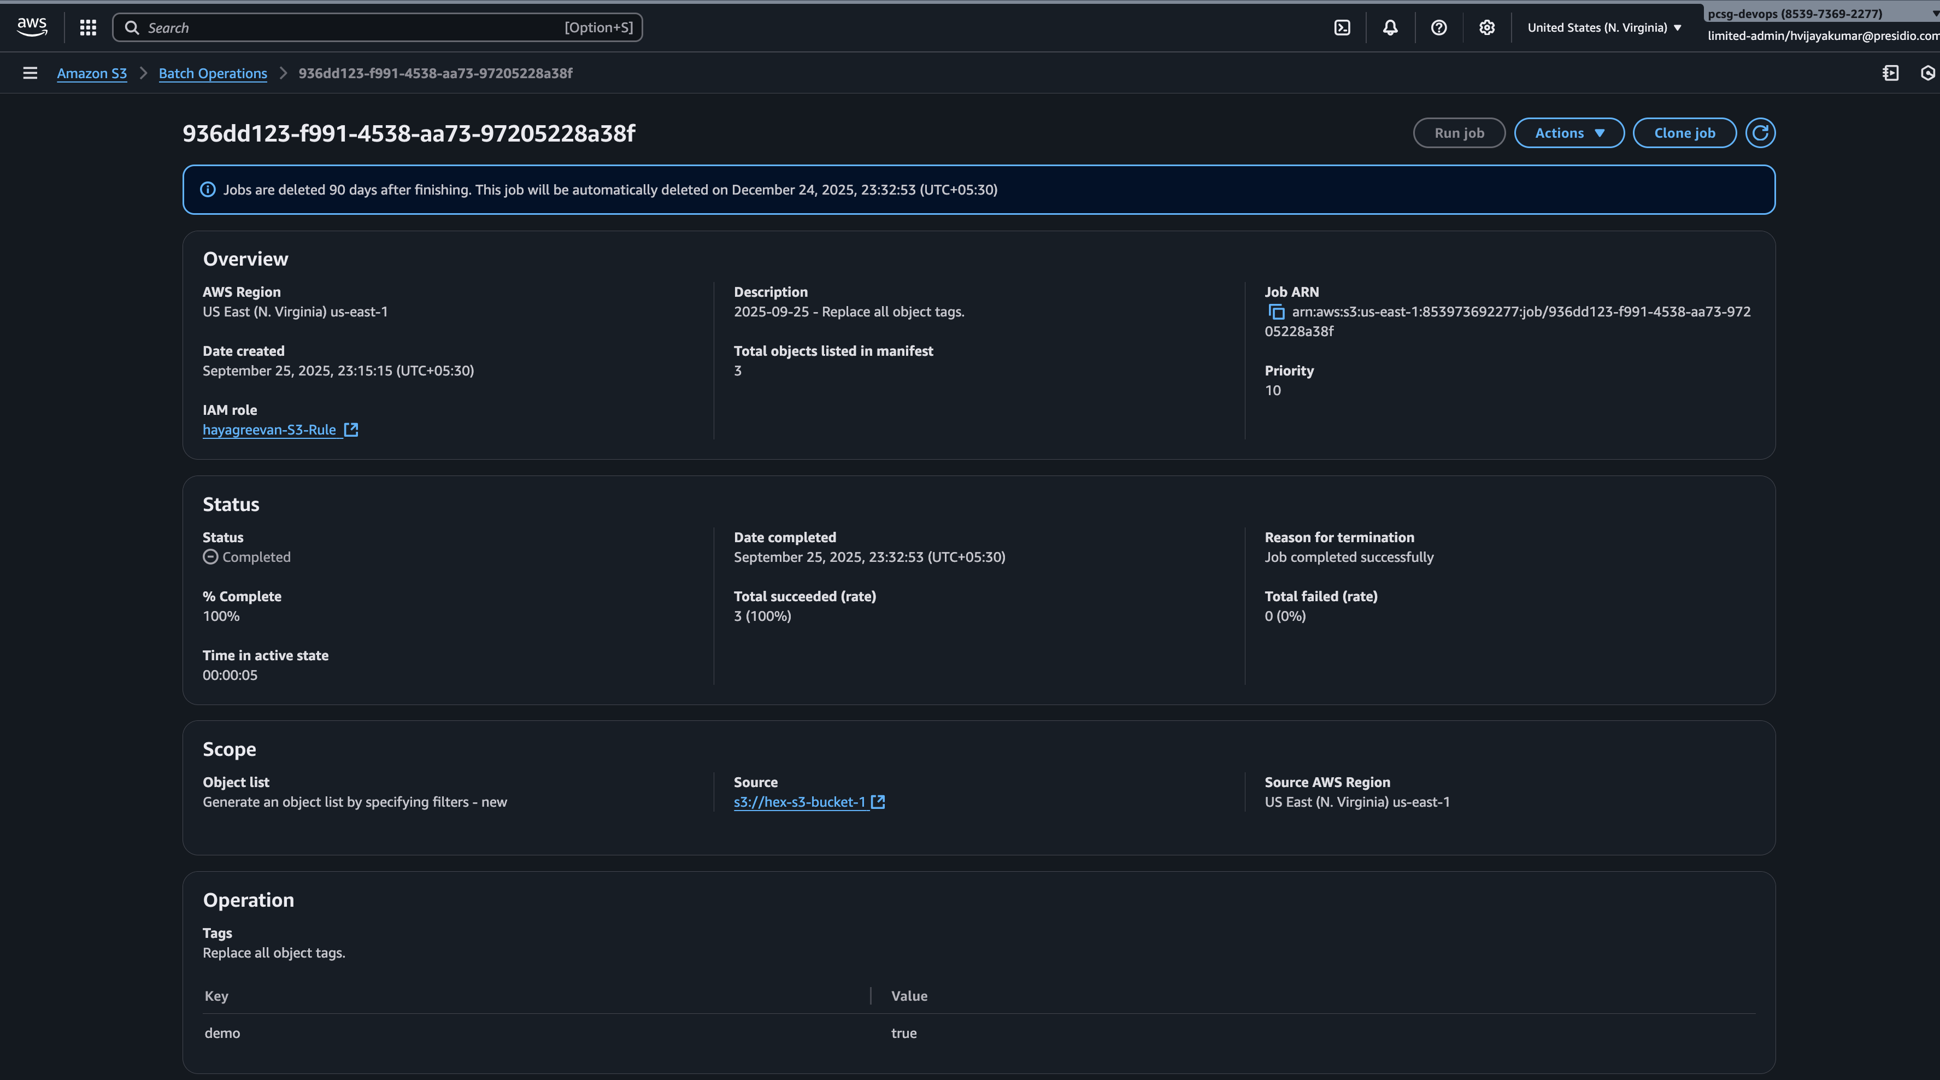

1. ﻿﻿﻿Implement S3 cross region replication for different buckets. Make sure it replicate existing and new objects.

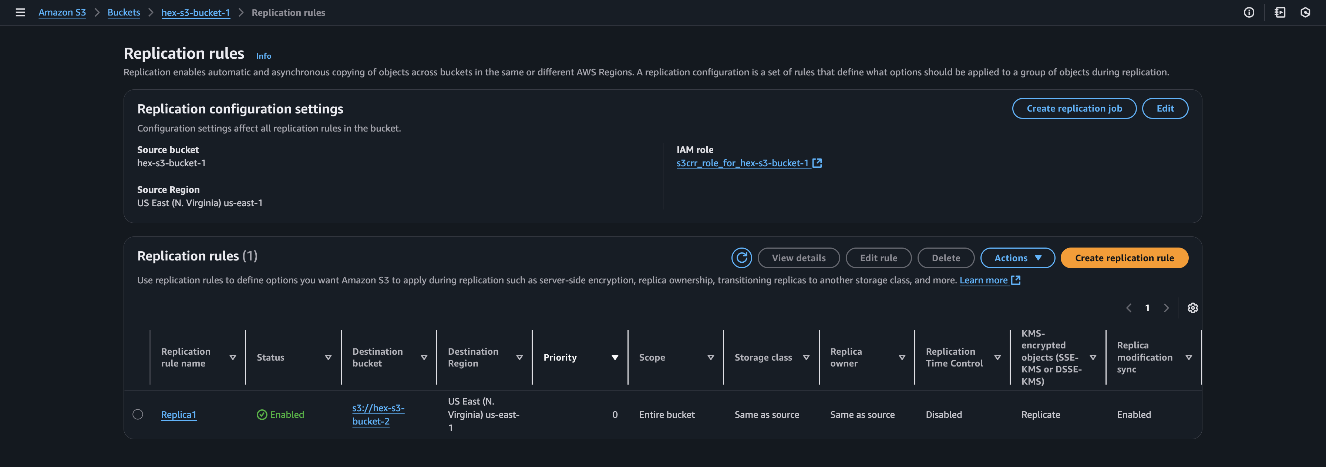

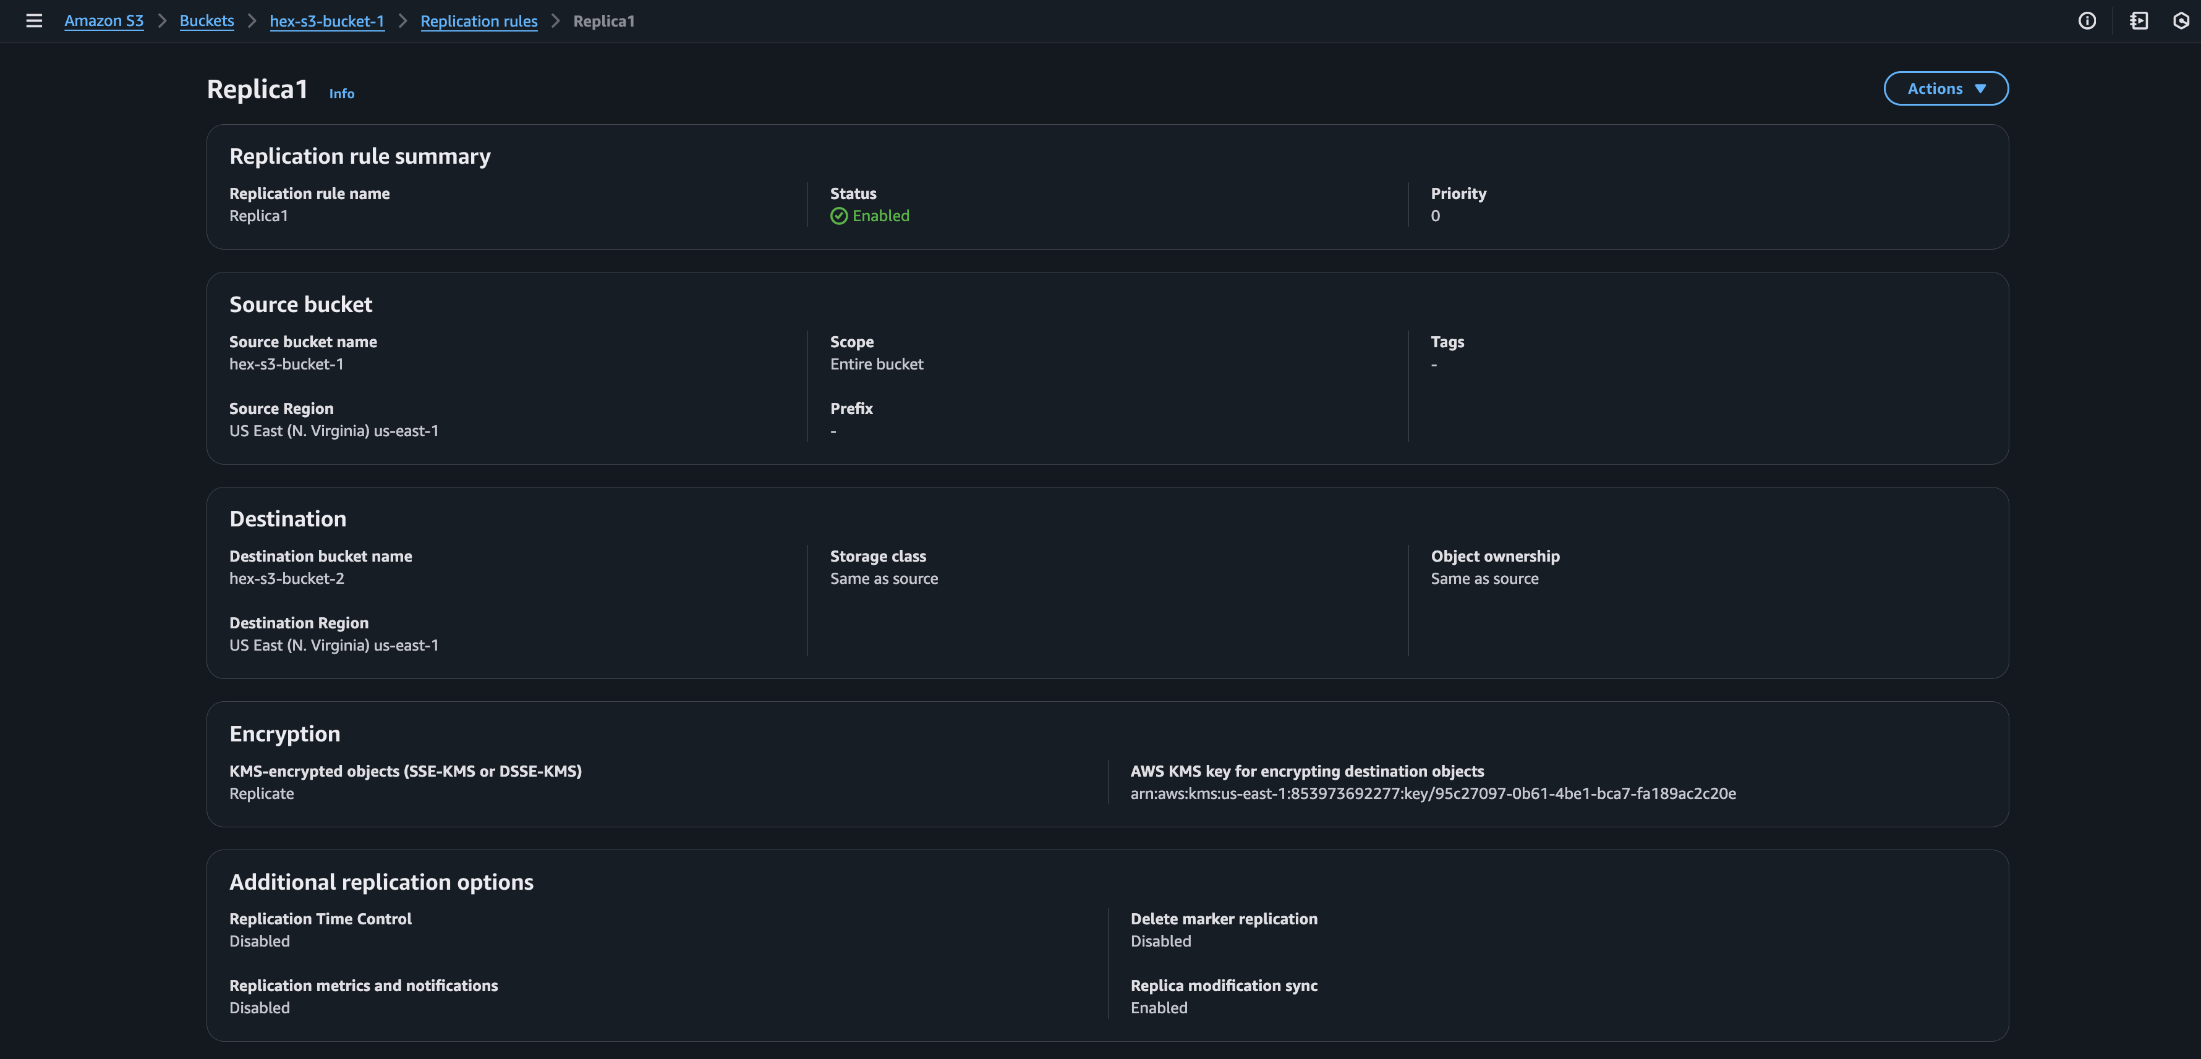

**Bonus Challenge:**

* Replicate new and existing objects from S3 Bucket A from Account A  to Bucket B from Account B. Both buckets should have KMS as encryption methodology.
* How encryption will be handled when during object replication from source to destination buckets.